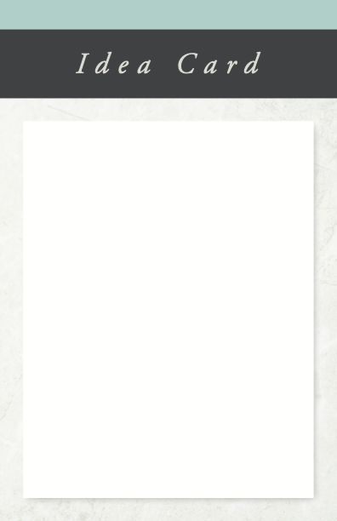

**IDEA CARD**

Family with YOUNG KIDS

**During the Family Time**

Follow these steps to have a great experience:

1. Assemble the blocks from largest to smallest or have the child help you cut the wood/paper into pieces of various length.
2. Have a child write one of the following words on each of the longer pieces representing the *“Should Do”* activities in his or her day: Sleep, Eat, School, Bathe, Chores, Read, Pray, Practice, etc.
3. Now have them write one of the following *“Could Do”* words on each of the shorter pieces of wood: Television, Games, Play with Friends, Play with Toys, Eat Ice Cream, etc.
4. Invite the kids to your *“24 Hour Table”* or flat surface. (Be sure the length of the surface is shorter than the combined length of the wood/paper blocks.)
5. Invite each child to design his or her ideal day by selecting the ones that represent what they would like to do most and placing them end-to-end on the surface until they run out of table. The child will quickly discover that there is not enough room on the table for several of the *“Should Do’s”* such as *“bathing”* or *“sleeping”* or *“school.”*
6. Now invite each child to place the pieces on the *“24 Hour Table”* in order of importance – deciding which of the *“Could Do”* blocks should be lowest priority. Share that we should protect some time for fun activities, but we might not get to do everything we enjoy every day.
7. Read Ecclesiastes 3:1 and Matthew 25:14-29 together and discuss ways to become wise with the time God gives us.

**Memorize:** *“Should Do before Could Do!”*

**Pray:** Close your time together in prayer, asking God to help you put the *“should do’s”* before the *“could do’s.”*

© 2009 Inkling Innovations

**TIME WISE**

___________________

**Best Use**

Use as a family time activity to illustrate the importance of using our time wisely.

**Advance Preparation**

Have the following supplies ready for family time:

* About ten toy blocks, wood pieces, or pieces of paper of various lengths
* A coffee table or flat surface shorter than the combined length of the blocks, wood pieces, or pieces of paper
* A marker
* A Bible